Yicheng "Catherine" Wang

Xinshi Wang

Mingxuan Shi

1. In the current solution, strawberries are not grown in field 1. From looking at reduced costs, determine what the yield for strawberries in field 1 would have to be to make it attractive to grow them there?

To determine the yield for strawberries whether they are attractive to be grown in field 1, we want to determine the reduced costs for strawberries in field 1 under growing, since the reduced costs reflect the change in yield from the current model. Indeed, grow["strawberries",1] is a nonbasic variable, so to make the yield attractive, we want to increase a nonbasic variable. Since it is the only nonbasic variable adjusted, so it reflects the change in yield directly. By looking at the reduced cost of the grow variable, we see strawbarries in field 1 have -45.5326. The absolute value should be the increase in the yield of strawberries in field 1, given that the objective function have coefficient yield["strawberries",1] for grow["strawberries",1]. It means that the yield for strawberries in field 1 needs to increase 45.5326 to make it attractive. Since the original yield is 272.297, the current yield is 272.297+45.5326=317.829.

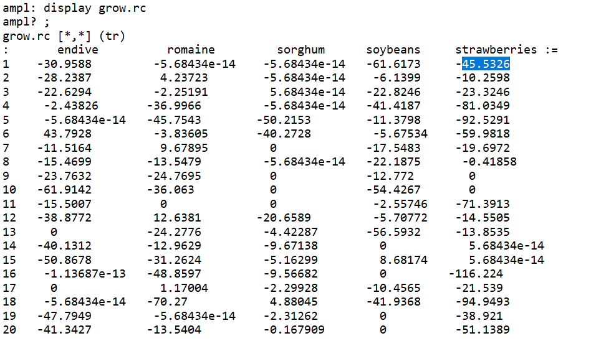

2. If the amount FarmCo is willing to spend on monitoring increases to 500, estimate change in objective function value.

In order to estimate the change in the objective function value, we need to find the rate of change in the objective function and the quantity of change. In this case, since the spending on monitoring increases to 500 with original 400, the total increase in spending is 100. To find the rate of change, we need to find the reduced cost for the slack variables in the inequality constraint, since when RHS is changed, it will directly reflect on the objective function. In this case, the reduced cost for the slack variable can be found by the value of dual variable, which is techavail.dual = 2.0 4667. Since the total change is equal to the change in quantity times the rate of change, so total change is equal to 100\*2.04667=204.667 and the current objective function value is = 8619.644+204.667= 8824.31.

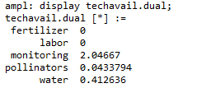

3. Use sensitivity analysis to estimate the improvement in the optimal value if the costs of monitoring are reduced by 10%.

To estimate the improvement in the optimal value, we need to find the rate of the change and the quantity of the change. In this case, since the costs of monitoring are reduced by 10% which means reduces to 9/10 of the original costs, to keep the amount of usage of technology not changing, the availability of using monitoring will increase to 10/9 of the original availability. Thus, the current availability increases 1/9 from the original availability. Therefore, the change in quantity is 400/9. To find the rate of change, we need to find the reduced cost for the slack variables in the inequality constraint, since when RHS is changed, it will directly reflect on the objective function. In this case, the reduced cost for the slack variable can be found by the value of dual variable, which is the techavail.dual = 2.04667. Since the total change is equal to the change in quantity times the rate of change, so total change is equal to (400/9)\*2.04667=90.9631. However, a change in the cost of monitoring will also change the cost in the objective function. The reduced cost of objective function on cost of monitoring in techcost is 3.04667. The current usage of the monitoring is 400 and since the costs of monitoring decreases 10%, the change in costs of monitoring is 400\*10%=40. So the change in technology costs is 3.04667\*40=121.867. In general, the change of objective function value due to the decrease in costs of monitoring is 121.867+90.9631 = 212.83.

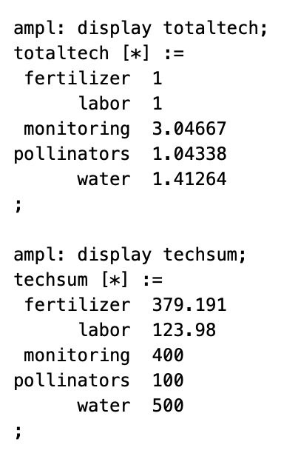 

4. Use sensitivity analysis to estimate the change in the objective function value if the value of propLB[’sorghum’] is dropped to 0.09. What about if we reduced propLB[’wheat’]?

To determine the change in objective function value, we want to find the rate of change and the quantity of change. Since propLB['sorghum'] is reduced to 0.09, the change in the lower bound for the revenue of sorghum is 1/10 decrease of the original lower bound of revenue. Since the original lower bound ratio is 0.1, the current is 0.09-0.1 = -0.01. Because the total revenue is 10122.8, the change in quantity is -0.01\*10122.8. To find the rate of change, we need to find the reduced cost for the slack variables in the inequality constraint, since when RHS is changed, it will directly reflect on the objective function. In this case, the dual variable of the constraint of sorghum is respectLB.dual = -0.041624. Thus the increment in objective function = 10122.8 \* -0.041624 \* -0.01 =4.21351. So if we reduced propLB[’sorghum’] is dropped to 0.09, the objective function will increase 4.21351.

If we reduced propLB['wheat'], as the above discribed, the change in quantity is -0.01\*10122.8, however, the dual variable of the constraint of wheat is respectLB.dual=0. Thus, the increment in objective function = 10122.8 \* 0 \* -0.01 =0. So there is no change if we reduced propLB[’wheat’].

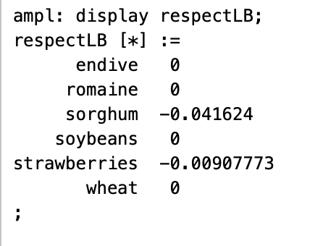

5. Use the command let availability[’monitoring’]:=500; and solve. Is the change in objective function value larger or smaller than your prediction in Question 2? Why?

The Objective function value is 8672.424679. It is smaller than the prediction. From the complementary slackness, we know whenholds, we have . When ****we have . Thus it implies when certain resource is not completely utilized (has surplus), the shadow price for the resource is 0; when the shadow price is not 0, the resource has been completely utilized in production. When availibility["monitoring"] = 400, the shadow price is 2.04667(techavail["monitoring"].dual) which means the resource has been completely utilized. However, when availibility["monitoring"] = 460 (or probably a lower qunatity), the shadow price is 0 (techavail["monitoring"].dual), which means the resource has not been utilized completely(has surplus) in the production process. Thus letting techavil equal to 500 will only create surplus rather than profit, but the sensitivity analysis in part 2 does not take that into consideration and assumed all the 100 extra quantity will generate profit.

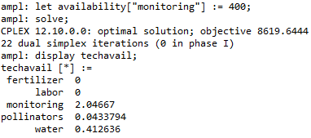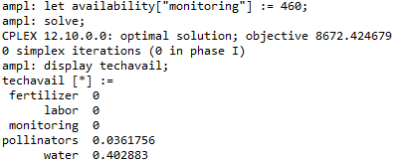

6.The answer you get in Question 1 should be greater than 300. However, using the command let yield[’strawberries’,1]:=300; and then solving, we see that strawberries are grown in field 1. How do you explain this?

The answer gotten from question 1 is 317.829 which is greater from 300. By looking at the original yield[’strawberries’,1]:=272.297 and the reduced cost for grow["strawberries",1] which is -45.5326, it implies that if we use simplex algorithm, we will pivot on the reduced cost for grow["strawberries",1], since it is the only negative reduced costs among the reduced costs. Looking at the crops grown on field 1, there are only two crops - romaine and sorghum - planted on the field which imply that there are only two basic variables that are romaine and sorghum. From the prediction, when the yield[’strawberries’,1]:=317.829, the reduced cost for grow["strawberries",1] is 31.0795 which implies that strawberries enter into the basis. Since from grow, there are only one strawberries being planted, it implies that sorghum and romaine leave the basic. Thus, strawberries are the only one grown in the field 1. In the previous, even though the simplex chooses to pivot on strawberries on the field 1, since it needs iterations to let strawberries enter into the basis, the objective function value does not change before that. By looking at the data for yield[’strawberries’,1]:=300, it shows that the reduced cost for grow["strawberries",1] is 0 which implies the strawberries enter into the basis before the prediction, even though it is not fully grown in the plantation. With the data from grow["strawberries",1], we can also tell the only two crops are planted, in the other word, the basic variables are romaine and strawberries with sorghum leaves the basis. Therefore, changing yield based on the reduced costs for a nonbasic variable will let the nonbasic variable enters into the basis with the original basic variables leave the basis, while pivoting on the LP will let the nonbasic variable that has negative reduced cost enter into the basis, but not maintain as the only one who is the basic variable becuase of the simplex algorithm. Therefore, it is possible for strawberries grown in field 1 before changing the yield based on the reduced costs by applying the simplex algorithm (pivoting on the negative reduced costs) towards the problem.

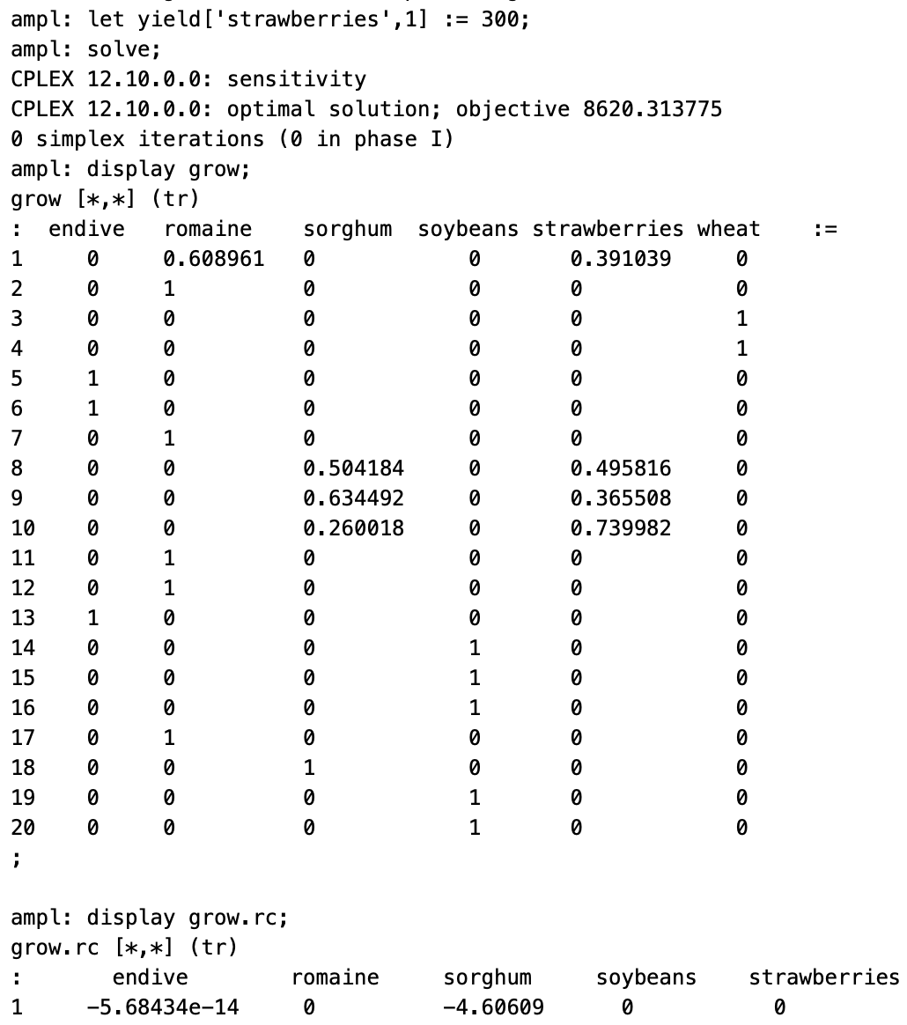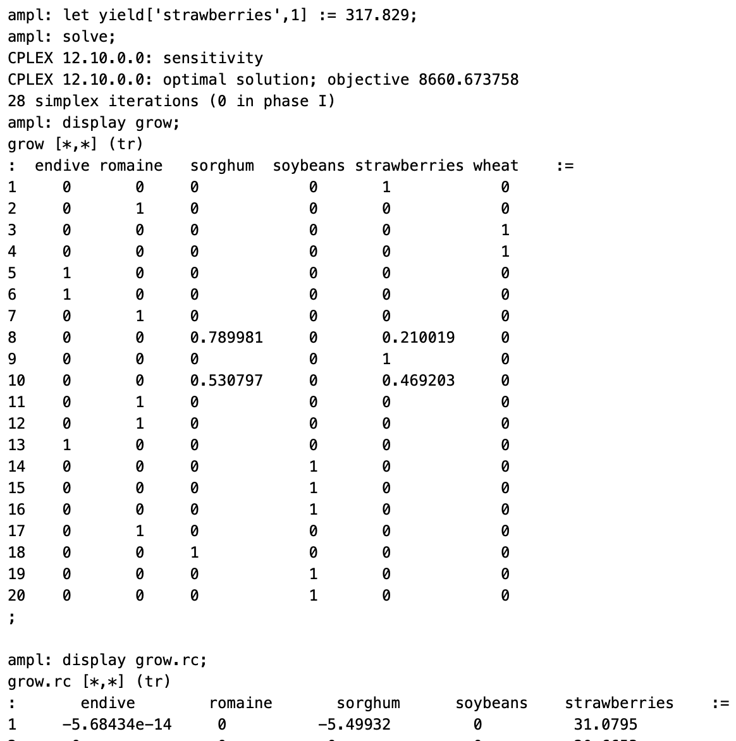

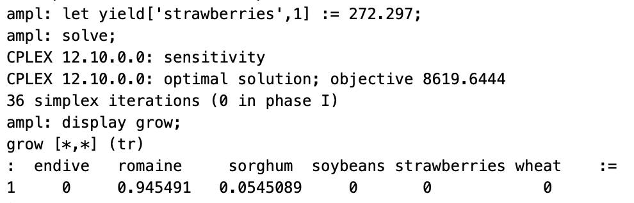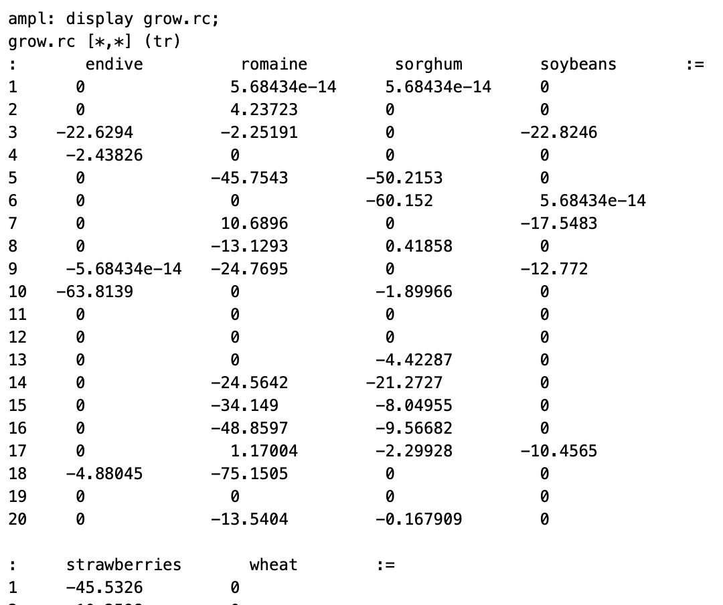

7. Use the command propLB[’sorghum’]:=0.09; and solve. Is the change in objective function value larger or smaller than your prediction in Question 4? Why?

From the prediction, the objective function will increase 4.21351 which means the predicted objective function value is 8623.86. When using the command propLB[’sorghum’]:=0.09, the actual objective function value is 8623.004667 with the change is 3.36067. Thus, the prediction is larger than the actual objective function. If the basis does not change, the shadow prices does not change either. However, the shadow price of respectLB in sorghum is -0.041624, it means the the basis does change. Thus, it implies that the prediction will be different from the objective function since the reduced cost change.

Now use the command propLB[’sorghum’]:=0.099; and solve. Is the change in objective function value larger or smaller than 10% of your predicted change in Question 4? Why?

From the prediction, the objective function value will increase 0.421356 (10% of the predicted change) which means the predicted objective function value is 8620.07. When use the command propLB[’sorghum’]:=0.099, the actual objective function value is 8620.065771 with the change is 0.421771. Thus, the prediction is larger than the actual objective function value. If the basis does not change, the shadow prices does not change either. However, the shadow price of respectLB in sorghum is -0.041624, it means the the basis does change.

